FCS 327 Postmodernism Influences of fashion
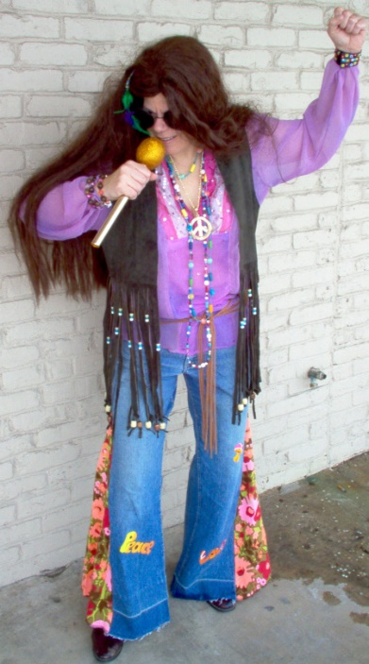
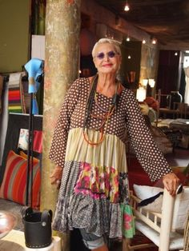
Death of Progress: In contrast with modern fashion that new styles arise and social trends progress, it seems that original design inspiration is being replaced with recycled looks like punk and hippie in these examples.

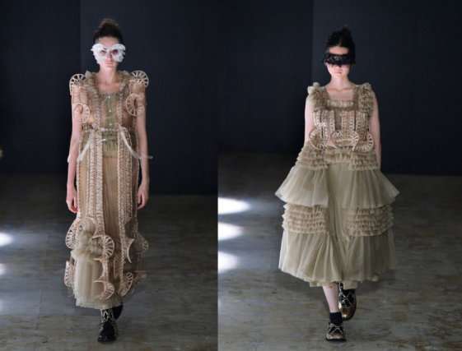
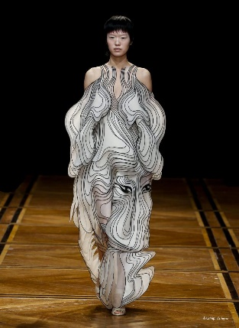
Volatile style change: a highly volatile and accelerated rate of fashion change, as compared with the rhythmic cycles of change in modem culture; Alternative solution to traditional stitching technique were proceed for creating shadows by twisting, braiding, cutting, and folding fabrics as well as creating sinuous volumes by anchoring fabric to wires and frames. The other fashion item, designed by Iris Van Harpen, takes wearable art to a new level, the ‘Symbiotic’ volumes are made from gradient- dyed silks that are multi-layered into sculptural shapes by a fine 3D laser cut frame of PETG.
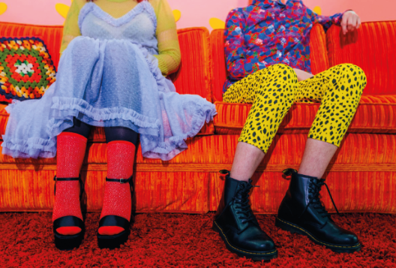
Rejection of authority; suspicion of narratives: The modern rule following stable aesthetic code in clothing items such as being worn in coordinating colors, styles, and types of garments is not followed in this example. Hence, it is a good example of postmodern rule.

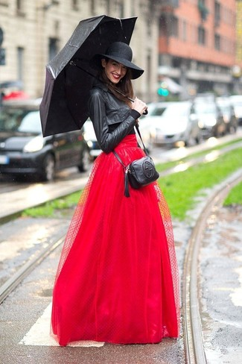
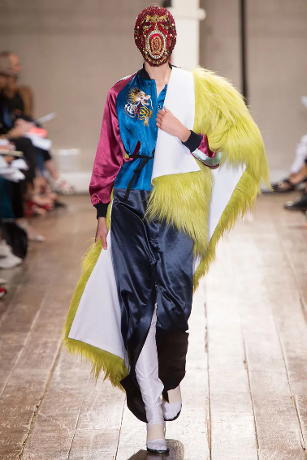
Disordered Combinations of Fabric and styles: Items in the pictures disregard modernist assumptions about unity and harmony in dress. They expressed themselves in disorderly combinations of garment styles or fabric designs and the use of incongruous elements in a single outfit. For example, a tulle skirt worn with a leather jacket, or combination of fur, satin, and leather.

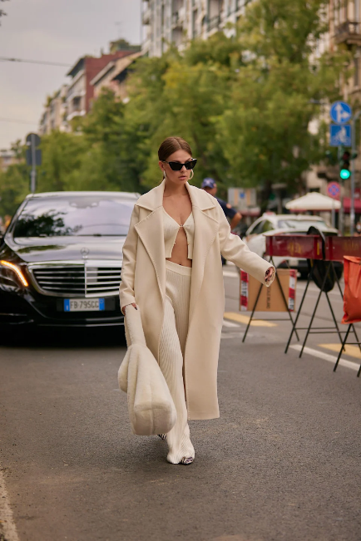
Death of art: the collapse of distinctions between elite, mass, and street fashions made this picture a good example of postmodernism


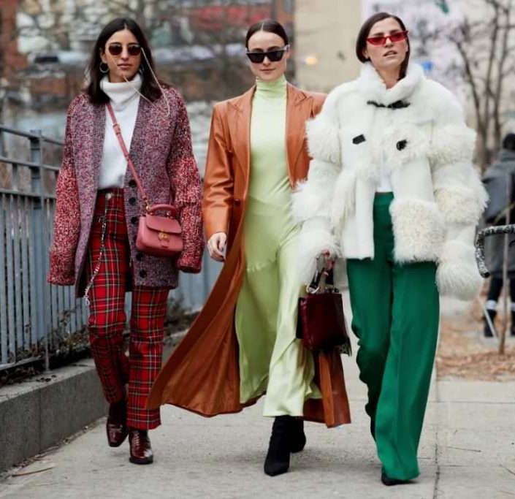
rejection of authority: the legitimization of fashions which originate on the street and from people’s taste and creativity in styling (mix incongruous items, folding sleeves cuff) rather than in professional design studios are illustrated by these pictures.

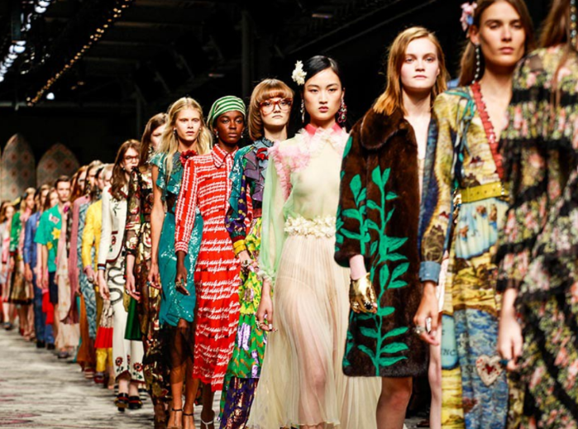
Heteropia: This picture depicts diversity and numbers of trendy clothing and appearance styles, compared with the selective designation of fashionable styles in modernist rule.

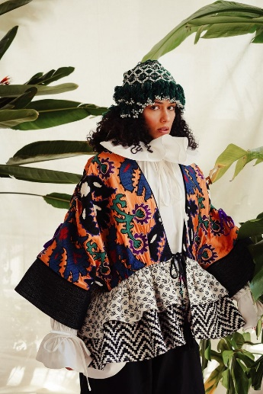
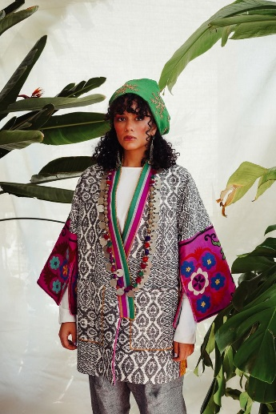
Decentering: Emerging the high visibility of previously marginalized ethnic and subcultural styles in modern culture.

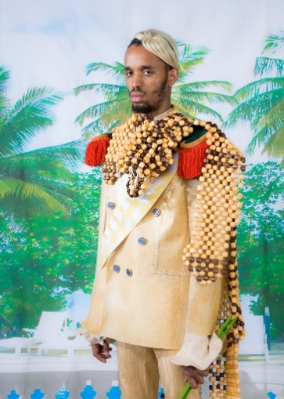
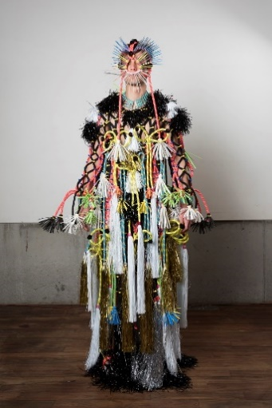
Bricolage: An emphasis on ornaments and decoration from a diverse range of available things, as compared with the modernist emphasis on simplicity and function is demonstrated in these two provided samples.

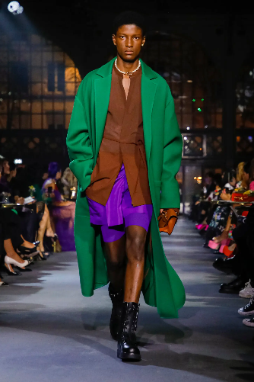
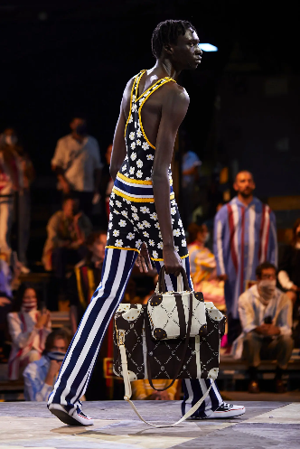
Suspicion of narratives: In contrast to modernism in fashion which adhered to cultural categories of time, gender, occasion, race, and status, the collapse of these previously meaningful rules specifically to gender, status, are sharp to see in these two examples.

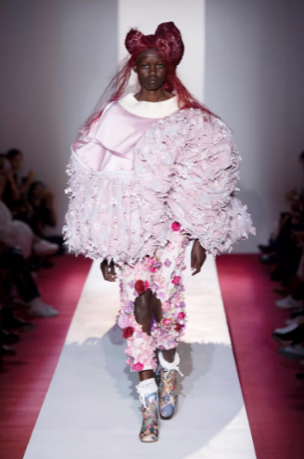
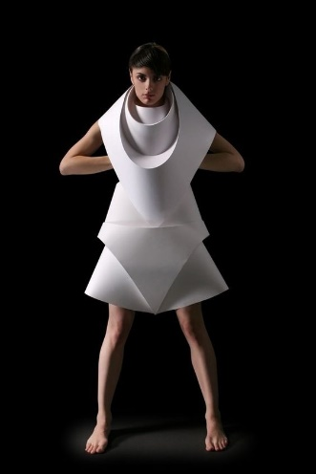
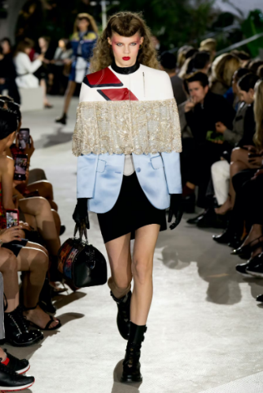
Deconstruction: disregard for assumptions about the naturalness of relationships between the structure of garments and the structure of the body, using uncommon shapes, volumes and materials explains deconstruction in postmodernism.

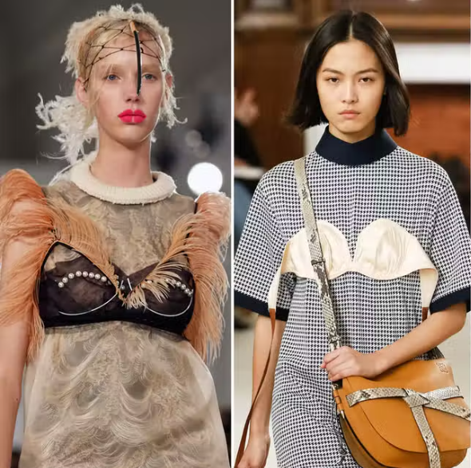

Deconstruction: In other way, it brings up challenges to traditional assumptions about how garments should be worn, expressed in undergarments worn as outer wear in this picture.

